BIMBY iNaturalist How to

Contents
Notes 3
Exporting data 3
Archiving Project at end of year 3
Include Users (Automation) 3
Members 3
DSF observation fields 3
Stats using Looker Studio 4
2024 Stats 6
DSF Colors R,G,B 6
Export Stats 6
Code APIs and DB etc 8
Python and API 8
Below is not necessary: 8

Notes

Exporting data
- First go to project, then -> click on observations
  - Then “export observations”
- When exporting Data directly from iNaturalist
  - Change the dates and taxonomy in the project
  - In the export data section
    - Select ‘place_state_name’
    - Select ‘taxon_family_name’
    - Select all ‘Observation fields’ (*)
* The user has to have used ALL the DSF observation fields themselves in order to be able to export the data. To be verified.

Archiving Project at end of year
- Go into current project
- Click “Duplicate Project” top right
- Change dates
- You will need to add members back into the “Include users”
  - Check the box “Only display observations from project members (people who have joined the project)”

Include Users (Automation)
- Extract the members list into an excel spreadsheet using the instructions below.
  - Delete columns A and C so you just have Logins
  - Save excel in “D:\PythonScripts\iNat\Duplicates”
  - Cd into D:\PythonScripts\iNat\Duplicates
  - Run Dup02.py

Members
- When existing iNaturalist members join BIMBY, their data from previous years get retrospectively added
- When members leave – we lose their data
How to export
Use the following web site:
https://kildor.name/inat/members
- Enter : butterflies-in-my-backyard-bimby-project
- Download selecting CSV file
- Open empty excel S/S
- Go to Data, Import…

DSF observation fields
- Extract:
  - Copy the DSF fields from iNat and paste in excel
  - Then use “text to columns” to turn the row into columns
    - Delimited
    - Delimiter = ‘other’ |
    - Copy and paste special select transpose in a new sheet
    - Delete other sheet
  - After that use “DSF Personal Transect.xlsx” file
    - Add new entries
    - Remember to add back in the “|” pipe symbol in column B
    - Then C is =A&B
    - Then D is a copy paste, values only
    - Then copy and paste and transpose again
    - Copy into iNat

Stats using Looker Studio
- Store G-Sheets at My Drive > iNaturalist > 2024 etc
- Use Looker Studio and link back to G-Sheets
  - Add Data -> G-Sheets
    - Remember to select appropriate tab
  - Edit any %s and set it to percent and precent (0)
  - Styles for tables
    - Show Title
      - Centre
    - No Row Numbers
    - No Show Pagination
- For map use – you need to edit the field and set it to an appropriate ‘type’
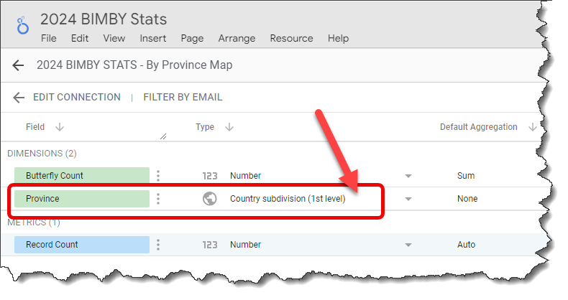

2024 Stats

DSF Colors R,G,B
- 123,172,212
- 123,156,147
- 0,95,135

Export Stats
- Edit BIMBY
  - to include plants and butterflies
  - do 3 months at a time (or even less)
    - Note: you can delete the time zone and precise times if you want to include whole days.
- Then go into
  - Download observations
    - Click on Observations -> then Export Observations
    - Select place_state_name in the GEO section
    - Select all in the Observation Fields
- Save as a spreadsheet
  - In field: plant association Replace all
https://inaturalist.ca/observations
with
https://www.inaturalist.org/observations

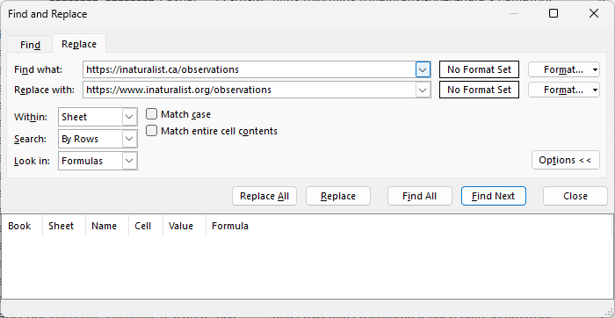

- Move the URL: column to the first column and sort by the 1st column
- At the end of the file, around AV and AW add
  - Plant Assoc and Plant Quality Column
    - Plant Association =VLOOKUP(AQ2,$A$2:$AZ$149322,38,FALSE)
    - Plant Quality =VLOOKUP(AQ2,$A$2:$AZ$149322,12,FALSE)
- Can do a copy and paste – values only to replace the formulas

Code APIs and DB etc
- iNaturalist API Get Observations
  - iNaturalist API Get Observations BIMBY

Python and API
How to run Python scripts - Hosting - Namecheap.com

Below is not necessary:
  - Create two tabs
    - Use copy tab
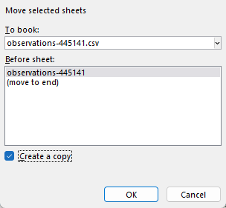
    - Filter and delete using “iconic_taxon_name “ - One for butterflies only
    - Filter and delete using “iconic_taxon_name “ - One for plants only
      - Rename tabs ‘plants’ and ‘butterflies’
- plants tab
  - Move url field to the first column
  - and sort it by 1st column/url
- butterflies tab
  - Freeze top row
  - Insert two columns after DSF Plant Association (1st)
  - Add vlookup columns x 2 after the DSF Plant Association (1st) column
    - Plant
      - =VLOOKUP(AQ2,plants!$A$1:$AU$36396,38,FALSE)
      - Column 38 is common_name
    - Quality Grade
      - =VLOOKUP(AQ2,plants!$A$1:$AU$36396,12,FALSE)
      - Column 12 is quality_grade
  - And make sure you are counting all rows!

